**Experiment No. 01**

**Object:** To create a cross-over and straight network cable

**Date:** February 03, 2018

# Description:

* To make a Straight & Cross-Over Cable using Cat 5/6 cable and RJ-45 Connector.

# Apparatus Required:

* Cat 5/ 5e/ 6 Cable.
* RJ-45 Connector.
* RJ-45 Clamper.
* Wire crimper.
* Network Cable Tester.

# Diagram:

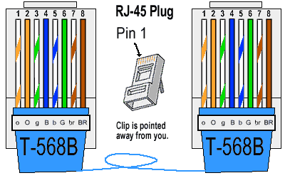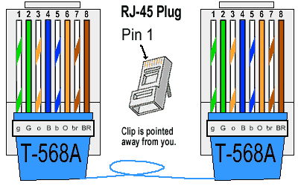

# Procedure:

* Crimp the given cable.
* Now, we have 4 pairs of wire (8 wires).
* Set the pair as you want for your desired cable.
* Arrange the cables in the form as directed in the picture.
* Put those wires in connector.
* Use clamper to clamp and made the pin sealed

|  |  |  |
| --- | --- | --- |
| **Straight Cable** | | |
| **Side A** | **Side B** |  |
| White Orange | White Orange |
| Orange | Orange |
| White Green | White Green |
| Green | Blue |
| White Blue | White Blue |
| Blue | Green |
| White Brown | White Brown |
| Brown | Brown |

|  |  |  |
| --- | --- | --- |
| **Cross-Over Cable** | | |
| **Side A** | **Side B** |  |
| White Orange | White Green |
| Orange | Green |
| White Green | White Orange |
| Blue | Blue |
| White Blue | White Blue |
| Green | Orange |
| White Brown | White Brown |
| Brown | Brown |